# DAW (Dispense as Written) and RBP (Reference Based Pricing) Cost Difference

Reminders and Copay Example

Claim Example

DAW Cost Difference

Brand Name Preferred (DAW 9) and Substitution Allowed (DAW 5) Brand as Generic Drugs

RBP (Reference Based Pricing) Cost Difference

Explanations of the Cost Difference

Related Documents

**Description:** Provides information about when members may have the option to obtain coverage on brand medications when available. The plan may choose to offer a certain amount of coverage towards the medication. If a brand is chosen when it has a direct generic available, then the member usually pays the difference between the brand and generic along with the appropriate copay. Afterwards, the client pays the remainder.

|  |
| --- |
| Reminders and Copay Example |



* Refer to the client’s CIF to determine if any Cost Difference exception for a DAW 1 or DAW 2 is allowed/applicable.
* Run a Test Claim for DAW 1 and DAW 2 to determine if there are differences in the cost.
* Members may have the option to obtain coverage on brand and/or generic medications when available. If a brand is chosen when it has a direct generic available, then the member pays the difference between the brand and generic cost along with the generic co-pay.

 Refer to this as a DAW Cost Difference. Do not refer to it as a DAW penalty.

**Example:**

Total Cost Brand: $100

Total Cost of Generic: $20

Generic Co-Payment: $10

* $100 - $20 = $80 dollar DAW Cost Difference
* $80 + $10 (co-payment) = $90 member copay

Top of the Document

|  |
| --- |
| Claim Example |

Displayed on the Prescription Detail screen, using **DAW 1 – Physician** and it may be applicable with other DAW codes.

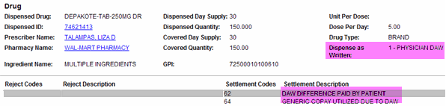

Top of the Document

|  |
| --- |
| DAW Cost Difference |

Financials screen of member’s cost with the copay and DAW difference highlighted.

** Do not refer to the DAW Copay as a penalty.** Refer to it as a DAW Cost difference.

 DAW Cost Difference does not apply towards the members MOOP.

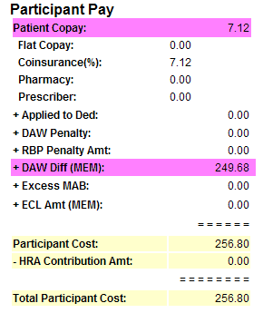

Top of the Document

|  |
| --- |
| Brand Name Preferred (DAW 9) and Substitution Allowed (DAW 5) Brand as Generic Drugs |

 These codes should not be discussed with the members.

 Do not use internal jargon with the caller such as “DAW” and “codes.” Explain in plain language as shown below:

* **Substitutions Allowed (DAW 5):** This means that the prescription can be filled with a **Brand** name medication, but the member is charged at the **Generic rate**.Thisis known as “[Branded Generics (059091)](https://thesource.cvshealth.com/nuxeo/thesource/#!/view?docid=e4b59eca-33ba-4e5c-bb8f-e54669906f71)” and is processed as a DAW 5. Refer to [Dispense as Written (DAW) Codes (040459)](https://thesource.cvshealth.com/nuxeo/thesource/#!/view?docid=7e5c2587-d679-4b42-b9b1-e98b754c6bff).
* **Brand Name Preferred (DAW 9):** The brand-name drug is a preferred and is a covered option versus substituting with a generic. When medications are filled, the member is charged the generic co-pay while allowing the pharmacy to dispense the brand-name drug. This practice is due to the generic cost being more expensive than the brand cost. When the generic is more expensive, the claim rejects as not covered. Refer to [Commercial as Tier 1 Preferred (DAW 9) (049768)](https://thesource.cvshealth.com/nuxeo/thesource/#!/view?docid=294e5d29-e781-4b76-b80a-4623740b9913).

**Note:** Review the CIF for client specific drugs that maybe impacted.

 Not all clients participate in the DAW 9 and/or DAW 5 process. **Do not instruct the member or pharmacy to have a physician write “DAW 9 or DAW 5” on the prescription**. This should not be considered a standard process and may cause a delay in dispensing. Instead, advise that the prescriber should write the prescription as “substitution allowed.”

 Do not tell the member that the Retail pharmacy processes a “DAW 5” claim using this practice. This is only applicable to Home Delivery/Mail Service.

Top of the Document

|  |
| --- |
| RBP (Reference Based Pricing) Cost Difference |

This Cost RBP Difference is like the DAW Cost Difference with a slight variation. Members may be given coverage to obtain brand and/or generic medications within a certain drug class. However, the client may select (or have the PBM select) the most clinically sound and cost-effective medication(s) within the drug class.

Next, they set the limit for how much is paid towards a medication within that drug class. The member may select a non-preferred medication and pay a price difference between the preferred medication and the non-preferred medication plus the applicable copay. The client pays the remainder.

 Donot refer to the RBP Copay as a penalty. Refer to it as a Cost Difference.

**Example:** Test Claim for a medication where a RBP Cost Difference was assessed.

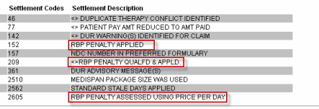

**Example:** Financials screen of member’s cost with the RBP Cost Difference shown.

 DAW Cost Difference does not apply towards the members MOOP.

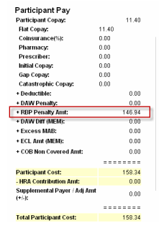

Top of the Document

|  |
| --- |
| Explanations of the Cost Difference |

Before providing an explanation, remember that the members are concerned with how this issue affects them. We are committed to helping our clients and members with choosing clinically sound and affordable drug therapy.

Today, most drug classes offer several options. Some are higher-cost brand name drugs and others are lower-cost generic options. Choosing a generic medicine can save you money each time you fill your prescription while still safely and effectively treating your condition.



If a brand is chosen when it has a direct generic available, then the member pays the difference between the brand and generic cost along with the Brand or generic co-pay (client specific, check CIF for DAW Drug Rules).

 There is a generic version of the medication available. This option is less expensive and is safe and effective for conditions in the drug class. If the brand medication is chosen to fill prescriptions, there is a higher cost. The member should discuss these and other treatment options with their physician.

**Note:** We do not provide clinical advice, so if the caller has questions clinical in nature, transfer to clinical or refer to their MD.

**Reminders:**

Icon - Important Information Do not blame the client for making the decision. It is possible that this may have been the only option that they could afford when providing comprehensive healthcare to their members.

* Always show empathy for the members’ concerns.
* Avoid calling the additional DAW Copay a penalty as this can cause distress for our members. Refer to the DAW Copay as a Cost Difference. (Reference above example.)
* Implying these types of Cost Differentials helps create a more consumer (member) driven, prescription plan.
* It gives our members the opportunity to have more control over their own healthcare, which may lead to a more active role in pursuing healthy options.

**Note:** The prescriber makes the ultimate determination as to the most appropriate course of therapy.

* Keep the focus on what the members can do.
* The list of preferred medications is non-biased, quality driven, and evidence based. The medications are selected based on the clinical merit of the drug and not always the cost when making the primary consideration.

Your plan gives you options for coverage to give you a more cost-effective price. There are medications that may save you more money overall. Would you like for me to determine what similar medications are available at a lesser cost?



* + If **yes**, run Test Claims for pricing and locate alternative medications. Inform the member that the prescriber makes the ultimate determination as to the most appropriate course of therapy. The member needs to discuss this change with the prescriber and obtain a new prescription to receive the more cost-effective medication.
* Generics are the first line of therapy even over preferred brands.  The generics represented on the standard drug list reflect highly utilized, recently released, effective products in chronic categories including hypertension, high cholesterol, diabetes, depression, and many others.
* If a drug is medically necessary and all other alternatives have been explored, the member or doctor can request and appeal for a Brand Cost Difference Exception. Review the CIF for client specific appeals process. Refer to [Appeals (007339)](https://thesource.cvshealth.com/nuxeo/thesource/#!/view?docid=cd7126d2-19b7-4743-913c-8e9dd7329c08).

Top of the Document

|  |
| --- |
| Related Documents |

[Customer Care Abbreviations, Definitions, and Terms Index (017428)](https://thesource.cvshealth.com/nuxeo/thesource/#!/view?docid=c1f1028b-e42c-4b4f-a4cf-cc0b42c91606)

Top of the Document

Not to Be Reproduced or Disclosed to Others without Prior Written Approval

**ELECTRONIC DATA = OFFICIAL VERSION / PAPER COPY = INFORMATIONAL ONLY**